Original Article
Halicin-Rifampicin Combinations are More Effective Than Monotherapy Against Biofilm-Residing Staphylococcus aureus and Prevent Emergence of Rifampicin Resistance

Joash R Suryavanshi^{1,2,*}, Akira Morita^{1,2,3,*}, Allison J Wintring^{1,2}, James E. Slaven⁴, Dalton A Walsh¹, Shota Higashihira³, Roman M Natoli^{1,2}, Edward M Greenfield^{1,2,5}

1 - Department of Orthopaedic Surgery, Indiana University School of Medicine, Indianapolis, IN, USA.
2 – Indiana Center for Musculoskeletal Health, Indiana University School of Medicine, Indianapolis, IN, USA.
3 – Department of Orthopaedic Surgery, Yokohama City University, Yokohama, Japan.
4 - Department of Biostatistics and Health Data Science, Indiana University School of Medicine, Indianapolis, IN, USA.
5 - Department of Anatomy, Cell Biology, and Physiology, Indiana University School of Medicine, Indianapolis, IN, USA.
* Corresponding Author
Joash Suryavanshi, MD
720 Eskenazi Ave, FOB 2nd Floor, Room F2-163, Indianapolis, Indiana 46202
Joash.Suryavanshi@gmail.com

Supplementary Material
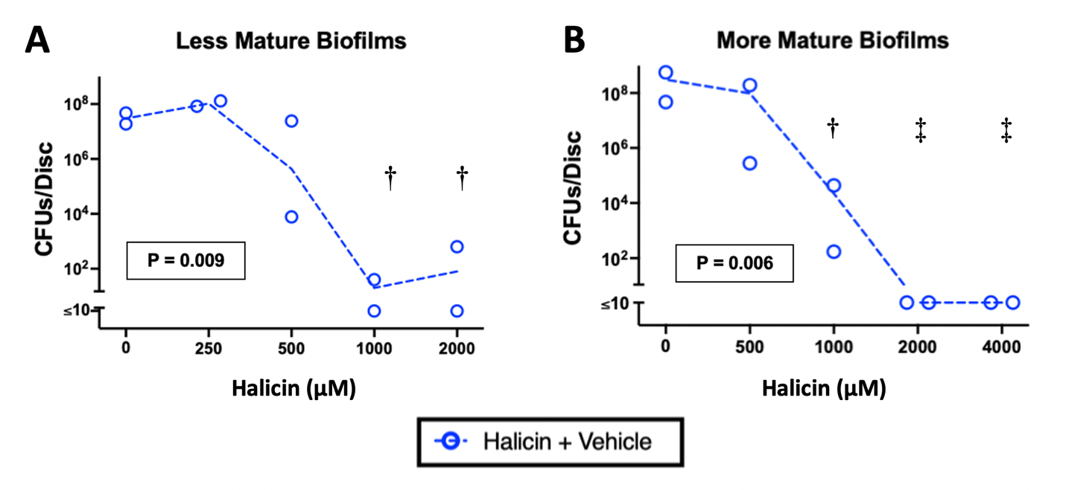
Supplementary Fig. 1: The MBEC of Halicin monotherapy on less and more mature biofilms grown on titanium discs is 1000 µM (A) and 2000 µM (B), respectively. Less-mature (A) or more-mature biofilms (B) were incubated for 20 hours with the indicated doses of halicin (blue circles). The final concentration of the vehicle in all wells was 2.5% Kolliphor-HS 15 (A-B). Dotted lines connect geometric mean CFUs of n = 2 independent experiments. Symbols denote the geometric mean for each group from an independent experiment, with 4 biofilms per group. P values comparing treated groups to the vehicle control group were determined by 1-way ANOVA with Dunnett’s multiple comparisons testing. †: p < 0.03, ‡: p < 0.006. The figure was designed using GraphPad Prism, version 10.3.1, GraphPad Software, San Diego, CA.

